Globalisation and the Environment—the CONUNDRUM

Pradeep S Mehta
CUTS International

January 11, 2006

Introduction

The world population at present is estimated at around 6bn people but has the potential to rise to 8.3bn in the next twenty years. (IPC, 2003) In order to support such an increase, this will mean more dependence on the environment and potentially further utilisation, or even exploitation, of its natural resources. Yet neither science nor technology, at present, has been able to create unlimited natural resources. And the effects of the industrial revolution on the environment are coming to the fore, making current environmental problems an issue for the entire world rather than for individual isolated groups. In the context of natural and human-induced disasters alone, over 6mn deaths were caused between 1995 and 2003.

Globalisation is the realising of international integration of people, technology, markets and governance. This can provide the opportunity of international co-operation at an increased rate and more effective rate to achieve global environmental objectives set out by Multilateral Environmental Agreements (MEAs). Though this opportunity is not always captured and sometimes surpassed, as observed for the most part of the 21st Century.

In the context of this paper, the connection between globalisation (in terms of market forces and governance) and the environment will be explored. The aim is to give further understanding of such relation, and offer thought on how globalisation can be managed for a sustainable environment. At the outset, in Section I of the paper, the inherent linkage of the environment and the process of economic growth (via the opening of markets and foreign direct investment, two fundamental aspects of globalisation) is illustrated. The alleviation of poverty and its relation with the environment is further surveyed in Section II. Once this setting has been established, then an analysis of global market forces and their interaction with the environment follows in Section III. At last, economic governance, by way of the World Trade Organisation (WTO) and its ambiguous linkages with environmental matters is analysed in Section IV. Concluding remarks are briefly offered in Section V.

I. Economic Development and the Environment

Assuming that globalisation through its components, such as trade liberalisation and foreign direct investment, has led to economic growth in both developed and developing countries, which understandably has its critics; it has been questioned as to whether such growth is to the detriment or to the enhancement of the environment.

Studies often cite the environmental kuznets curve to explain the linkage between economic growth and pollution:

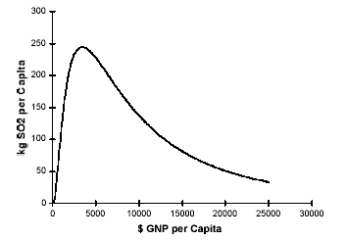
Source: Stern, D. I., Common, M. S., and Barbier, E. B., (1996) ‘Economic growth and Environmental degradation: the Environmental Kuznets curve and Sustainable development.’ World Development

The curve illustrates that in the initial stages of development or at early industrialisation of a country, the environment depreciates; however as countries gather middle-income levels between $5000 and $8000 per capita GNP, the environment tends to recover and even improve. This outcome has been suggested due to the following occurrences at higher levels of income: there is greater access to environmental technologies and at the same time societies with more riches prefer more environmentally friendly goods. Though it must be clear that this is not always the inevitable result, pollution may still rise as a result of expanding economic activity and greater consumption made possible by more wealth, outweighing the aforementioned occurrences. Indeed Bhagwati indicates that the outcome derived by the environmental kuznets curve ‘should not be used to argue that growth will automatically take care of pollution regardless of environmental policy.’

Groundbreaking research suggests that a country’s development/industrialisation stage affects, but does not alone determine, environmental outcomes. (Esty D.C. and Porter M. E., 2005). There were great differences determined in environmental performance between countries at the same stage of economic development. For example in terms of air quality, measured by the average annual airborne dust (urban particulate) concentration per city population, in 2000, though Mexico is at a higher level of GDP per capita as Brazil, the former has much worse air pollution (measured at 279.0 on average) compared to the latter (who averaged around 106.2). Similar instances can be abstracted from other countries in the following graph:
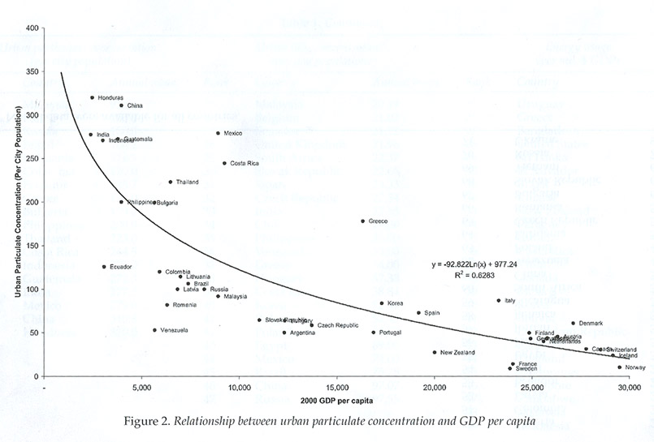
Source: Esty D.C. and Porter M. E., 2005

At the same time, the graph indicates that developed countries have better air quality than less developing countries. This is understandable as on the basis of the environmental kuznets curve, the higher the income the more likely that better environmental quality shall be achieved in the long run.

More interestingly, the results indicate that environmental performance can be improved, independent of the gains from economic development. There is potential for countries to choose a different course and not use the quest of greater wealth as an excuse to neglect their environment. The dynamism of a country’s environmental regime and the setting where this regime operates, in terms of the legal and economic context, will play a major part in the course of a country’s development. It has been highlighted that there are two routes for countries to select in order to gain high levels of both income and environmental performance (See Esty and Porter, 2005). Adjusting for income differences (economic development) the graph below represents a measure of a country’s environmental regulatory quality relative to expectations established by income level.
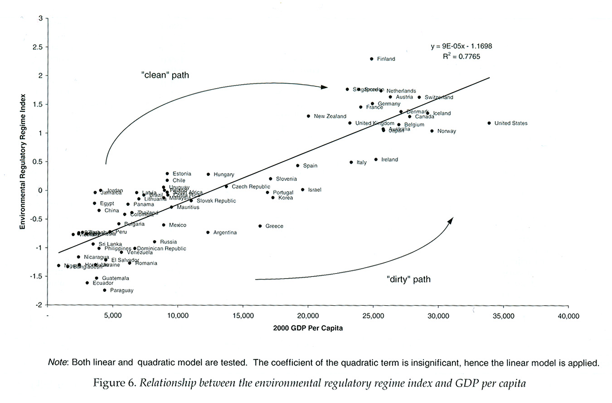 Source: Esty D.C. and Porter M. E., 2005

Countries such as Brazil, since their environmental regulatory quality advances ahead of economic progress, are deemed to have opted for a clean path on their way to economic development than their counter parts such as Mexico and Russia who move along a dirty path. Thus on the basis of such research, it can be asserted that environmental progress can be achieved without sacrificing economic progress and vice versa.

II. Poverty and the Environment

The Paris Declaration and the Programme of Action for the Least Developed Countries (LDCs) that was the outcome of the second United Nations Conference on LDCs in 1990 has amounted to little; regrettably, one of the major areas of the PoA was to turn round the movement towards environmental degradation. Such aim now coincides with the Millennium Development Goals, MDGs; more specifically MDG 7 to ensure environmental sustainability whilst recognising MDG 1 which aims at eradicating extreme hunger and poverty.

LDCs are lagging behind in receiving globalisation benefits without effective governance or structural change, and inequality actually is worsening. It is estimated that 2.74bn people, are living in poverty, earning just US$2 per day or less. Globalisation and opening up their economies to world markets through trade liberalisation has actually weakened their production capacities, as the prices of their main exports have been seen to be declining often due to developed countries subsidised exports that are seen to distort world prices. For instance in the case of cotton, one of the major sources of export revenue from some particular LDCs in West Africa, one is able to see the vast drop in world prices over the last 30 years in the graph below:

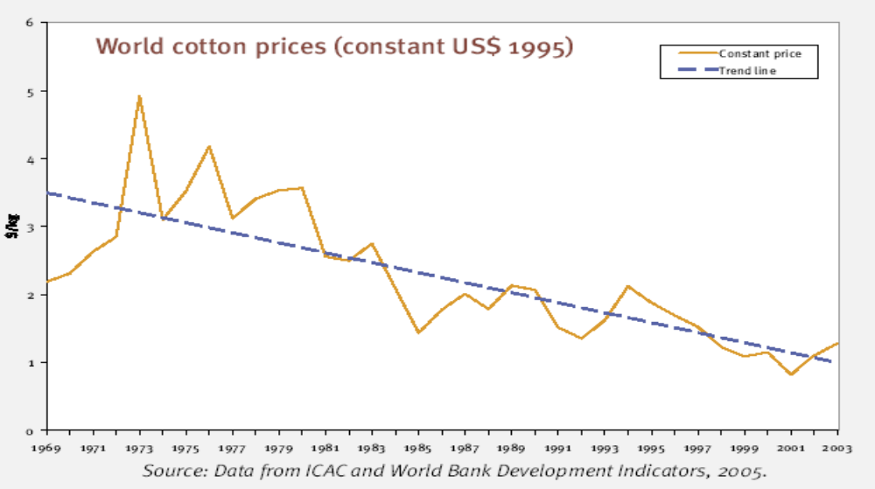

Though it must be said that the WTO has called upon the developed countries to remove such price distorting cotton export subsidies by 2006, but developed countries’ domestic support for their farmers remains, which still distorts world cotton prices (the WTO and the environment shall be discussed in section IV). The eventual removal of such subsidies would result in increased cotton prices. Consequently this would increase income from sales, which would be received by LDC farmers and may potentially lift them out of poverty. As previously asserted by the environmental kuznets curve, a higher income leads to the achievement of environmental objectives. For example as the poors’ income rises, the poor may pay for environmental energy rather than using fuelwood and dung that degrades the environment.

However, if domestic support is to remain in place and distort global market prices, this will leave LDCs and even developing country farmers in poverty; or perhaps lead to them transferring to environmentally degrading industries such as mining; or at the very worst being displaced for large TNCs that offer benefits of economic growth. For example in 2001, Peruvian peasants in Cajamarca were displaced for gold mining and forced to the city of Cajamarca where they had no way to make a living. Nonetheless, the rivers downstream of these goldmines were polluted by sodium cyanide (which is sprayed upon the ore extracted by these gold mines). This was detrimental to the livelihoods of the poor who were dependent upon these rivers for both water and food.

Further yet, at a low level of income, people living in rural areas depend on the consumption and sale of natural products for much of their livelihoods, and this statement certainly does not mean that the poor neglect the environment. Certainly, the poor rely directly on their surrounding natural resources and so often need to be careful environmental managers. It must be made clear that the environment is a necessity of the poor and there are many cases where the poor have been defending their environment. At the extreme, one finds oil extraction damaging natural habitats and the heath and survival of local communities. Across the Niger-Delta area of Nigeria, locals are constantly at loggerheads with multinational oil companies Shell, Chevron, Agip and Elf. But indeed, globalisation of civil society enabled the birth of Oilwatch, which united communities through networking across the southern region, to oppose the activities of oil companies in tropical countries.

On a different note, the implementation of environmental standards on the poor may cause further costs in terms of adjustment or foregone income in the short term, though it may be to their long-term benefit. Often environmental standards are suddenly inflicted upon the poor through prohibitions or restrictions. These standards can lead to many dire consequences, for instance, a local company’s cost of production to comply with such standards may increase, leading to a loss of employment or small firms closing down altogether. And with poor economic conditions alternative jobs are difficult to find, the main income earner of the family may be required to force other members of the family to take up jobs; at the worst, pulling their own children out of school to take up hazardous employment.

The implementation of Multilateral Environmental Agreements, generated through globalisation, must take into account the plight of the poor. Developing countries should be compensated for the environment that they conserve that has global rewards, such as preserving forests that absorb carbon emissions (which shall be discussed in the following section). If environmental standards are to be imposed, then alternative means of employment should be offered to the poor, so that they can be allowed to continue to achieve a higher level of income and in effect, attain higher environmental quality.

III. Addressing Global Market Mechanisms for the Improvement of the Environment

Globalisation has wrought the onset of global market forces that often traverse national borders as clouds cross the skies. The activities of production and consumption of goods and services are common internationally and are fundamentally guided by Trans-national and Multinational Corporations, TNCs and MNCs. But the mindset of profit maximisation by TNCs and MNCs often results in environmental degradation through the exploitation of natural resources, primarily caused by such natural resources being under-priced. For example, paper was regrettably under-priced in the late 1970s (although it unfortunately still is under-priced), Thailand with the aim of export-led growth initiated the conversion of tens of thousands of hectares of natural forest into plantations for eucalyptus to provide chips for paper mills owned by Japanese TNCs.

In addition to this matter, TNCs and MNCs are seen to maintain environmental costs such as air and water pollution, as an external cost to the company, that is to say an externality. Speth maintained that there should be a transition to ‘environmentally honest prices’ for a sustainable future, further acknowledging the multitude of economists’ beliefs that prices should reflect their full environmental costs (Speth, 2004). TNCs would then take into account the true environmental costs and aim to minimise them for profit maximisation. Such components of globalisation would then be seen to help maintain a sustainable environment. However without such honest environmental pricing taking place, TNCs rapidly expanding across the globe will cause further depletion of natural resources and cause more environmental damage in their production actions. At the same time, consumers will continue to buy TNC/MNC products that are priced without the additional real environmental costs, at an unsustainable rate of consumption. Current developments have thus triggered the negative view that globalisation has a damaging impact on the environment.

Needless to say, as world population is seen to be continuously increasing and economic growth is rising, more people have more money to spend, consuming more goods and services. One may ponder on the Aristotelian concept of the ‘insatiable desire for more.’ It has been estimated that 1.7bn people have entered the “consumer class” that was once limited to rich nations, to be sure, the booming middle class in developing countries see western lifestyles as a model to aspire to. Although this inevitably creates more jobs, global consumption is rising at an unsustainable rate. Agenda 21 raised this issue in 1992, observing that ‘the major cause of the continued deterioration of the global environment is the unsustainable pattern of consumption and productions particularly in industrialised countries’ (UN 1992, Chapter 4.3). Although economic growth is seen to benefit the environment in the long run, it also plays a part in determining a country’s amount of spending. For example China grows at a rate of 9-13 percent annually, and at the same time its’ demand for wood, concrete and fossil fuels has increased rapidly (Goodman, 2004). The opening of markets enables consumers to buy goods whether renewable or non-renewable at an increased rate and at larger volumes; considering more efficient global transport options. Hence there is great need of global governance and a re-orientation of consumer attitudes, which may consequently enable the consumption of nontoxic reusable products minimising the use of raw materials, energy and water. Not only environmentally honest pricing will promote sustainable consumption, consumer lifestyle changes must also be made. An effective consumer transformation can only be brought about through the globalisation of education and awareness generation for sustainable consumption.

With a different perspective, global market mechanisms are being managed in certain areas for the ascertainment of not only environmental objectives, but also development goals. One finds a great example of this happening with the directives adopted under the Kyoto Protocol’s Clean Development Mechanism (CDM) that finally entered into force on 16th February 2005 after its establishment in 1997. The CDM aims to minimise the cost of greenhouse gas emissions. Developed countries’ companies, in return for investing in a CDM sustainable development project in a developing country, earn Certified Emissions Reductions that developed countries may use to meet their Kyoto Protocol and national commitments. Companies are most likely to invest since these CDM projects are at cost below those normally experienced for domestic projects for attaining Kyoto/national targets.

To take such global environmental governance a step further, a pioneering proposal has been asserted by a group of ten developing countries, led by Costa Rica and Papua New Guinea, during the recent Montreal Summit on Climate Change. The coalition put forth that the CDM should promote projects that reduce emissions from tropical deforestation. The U.N. Food and Agriculture Organisation’s (FAO) report in 2000 showed that there was a net loss of 9.4mn hectares of forest a year during the 1990s. And emissions from such deforestation are the single largest source category of emissions from the developing world, and this tropical deforestation, moreover, is a significant part of global carbon emissions.

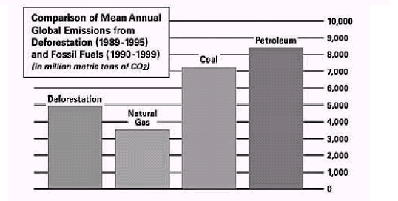
Source: Intergovernmental Panel on Climate Change & US Department of Energy

The parties aim to expand the current Marrakesh Accords to allow for crediting of projects that reduce emissions from tropical deforestation. Although such a proposal is in its initial stages of implementation, the course of direction would be supportive of both environment and development interests, with both objectives reinforcing each other. Such a response to combat global environmental damage could not have taken place but for globalisation consisting of the union of countries and TNCs to a common cause.

IV. The WTO and the Environment

Without a capable Global Environmental Organisation on the horizon, the WTO has taken up environmental issues under its umbrella to a certain extent. However it can be noticed, that every now and again, trade ministers within the organisation like to push the environment out into the rain when it seems no-one is looking. But what is definite is that the WTO is ever more under the eye of civil society. People are collectively beginning to be more environmentally minded and pro-active after the continuance of natural disasters caused by destruction to the global environment. Though the WTO may not have opened its doors to the public in response, it has begun to open a few windows to publicise certain operations; such as at the Dispute Settlement Body, where the legal proceedings of the continued EC – Hormones dispute were allowed to be viewed by journalists, NGO representatives and scholars from a separate room at the WTO headquarters (via closed-circuit broadcast).

Still, there is uncertainty as to whether the WTO should play major part to play in the governance of global trade and its impact on the environment.

WTO – A Protector of the Environment?

The WTO’s fundamental role is to liberalise trade, but whenever trade overlaps or conflicts with the environment, it falls in its lap resolve such conflicts. Article XX of the GATT does speak about such situations, but the jurisprudence which has developed has been to look at the ‘least trade restrictive’ approach to such problems. On the other hand, the WTO is also required to take into account trade and development linkages, which an be mutually supportive with the environment. While Bhagwati asserts, “the ‘best’ policy is to combine free trade with appropriate environmental policy,” this statement should be taken one step further. Trade policies that are price distorting, such as the aforementioned developed countries’ cotton subsidies that harm poor farmers should be eliminated; simultaneously trade policies that enable industries to remain inefficient and detrimental to the environment should also be removed. The WTO has the power in a sense to remove price-distorting mechanisms such as subsidies and protective actions such as anti-dumping measures that are found to support inefficient exporting industries, which can be detrimental to the environment due to their production processes.

Take for example the global shrimp industry and ‘the blue revolution’, which has devastated the environment not only because of lack of environmental policy but also via the support of subsidies. In the last few decades over 30 percent of the world's Mangrove forests, covering tens of thousands of miles of coastline, have been destroyed to make room for shrimp farms. In fact, exporting countries, comprising of mostly developing countries, now have some 110,000 warm-water shrimp farms, covering around 1.3mn hectares.

Environment and livelihoods—Conflicting Objectives

The Environmental Justice Foundation report noted that the world consumption of shrimp increased by 300 percent over the last ten years. As a consequence, a shift toward a "slash and burn" style of aquaculture took effect; where networks of large, human-made ponds that were made for shrimping, are abandoned after five or six years as a result of disease and poor water quality. In the upper Gulf of Thailand alone, 40,000 hectares of farms were abandoned by 2000, with 90 percent of shrimp farmers, in the area, thrown out of business. UNEP estimated that while intact mangroves are worth US$1,000 a hectare, in contrast mangroves’ value, cleared and converted for shrimp farms, falls to about US$200 a hectare.

Such rapid development of shrimp farming has led to harmful consequences. In the aftermath of the dreadful December 2004 tsunami, it became evident that areas with intact coastal ecosystems suffered much less damage than those where shrimp production had damaged mangroves and coral reefs. For instance, the Pichavaram mangrove swamp in Tamil Nadu, India, slowed down the waves, protecting around 1,700 people living in settlements built between 100m to 1,000m inland from the mangroves.

With a larger view, the shrimp industry is part of the global fisheries industry, which concerns the livelihoods of around 120mn people. It supplies food security to many people, and has huge potential to provide food security to many more, e.g. the global consumption of fish on average per person annually is 16.2kg, moreover, in small coastal countries such as the Maldives, Palau and Kiribati, the average rises above 75kg per year. Hence it is understandable that domestic support is provided to the fisheries industry through subsidies, considering that so many livelihoods are at stake.

But at the moment, subsidies given to the global fisheries industry vary between US$14 and US$20bn annually. A recent UNEP study concluded, “Most subsidies have the potential to be harmful to fish stocks particularly in the absence of effective management… Subsidies that contribute directly to increased fishing capacity or effort are among the most harmful”. As can be seen in the case of the shrimp industry, such subsidies enable the industry to remain inefficient and continue to fish at an unsustainable rate. In fact, nearly 70 percent of the world’s major marine fish stocks are either over-shed or being shed at the biological limit. Once fish stocks are completely depleted the impact on livelihoods will be devastating.

Now make room for the WTO. During the Doha Round negotiations, WTO members produced a mandate that aims to improve WTO disciplines on the global fisheries industry, and members are reciprocating to an extent, though at the moment little consensus has been achieved. However, there is great potential to prohibit subsidies that lead to over-capacity and over-fishing. WTO Members such EU and US have already proposed such an idea. The gradual removal of inherently large subsidies will enable for the continuation of sustainable fishing, both in terms of the environment and in the context of development.

WTO-A Hindrance to Environmental Objectives?

In contrast, there is always the opinion that the WTO sacrifices environmental objectives, for its mission to disperse trade liberalisation benefits. WTO rules can truly set back environmental interests that aim to promote environmental production methods, and to reduce non-environmental industries that damage the global environment; such as in the way PPMs have been and are currently handled by WTO rules.

Let us consider the events under way in the Doha Round. Provision 31(iii) of the Doha Mandate of the WTO has offered the opportunity for the liberalisation of environmental goods and services, EGS, which is of vital need to livelihoods in developing countries and to the environment in general. UNCTAD set a proposition to include Environmentally Preferable Products (EPPs) in the classification of these EGS. These EPPs comprise of goods such as organic products, non-timber forest products and related natural products. The inclusion of EPPs would imply an attractive enlargement of the EGS global market to developing countries since they boast comparative advantage in these sectors and are seen to be principal net exporters. In fact, this global EPP market was estimated to be worth around US$28bn in 2000.

So how is the liberalisation of EPPs being negated, well the reason is illuminated within the fine print of the GATT. EPPs’ environmental advantage arrives from their environmentally friendly production and processing methods (PPMs), though their actual end use may not be environmental. Nevertheless, WTO rules deem that measures taken against goods on the basis of their PPMs are forbidden. This is to reduce Governments discriminating against any goods that are not manufactured to their own environmental or quality standards, which would lead to further protection of their industries and restrict trade. Therefore the hitch is that the proposed EPPs would galvanise the issue of whether a country can place conditions of market access on a good in relation to its PPMs. At present, developing countries are divided in submissions to the WTO Committee on Trade and Environment. Brazil has sided with developed countries (EC, New Zealand and Switzerland) supporting the call for EPPs liberalisation, while Korea and China remain opposed.

This division amongst developing countries is understandable considering how the issue of PPMs was poorly handled by the WTO in the US-Shrimp case, which has led to developing countries fearing that by liberalising EPPs, could lead to discrimination and further restriction on other exports based upon their PPMs. Bhagwati highlighted the outcome of this infamous case, where the US prevented shrimp exported from certain developing countries being sold in the US market; such shrimp was not being caught in an environmentally friendly manner and causing the death of many turtles. The US argued that that the prohibition was to conserve natural resources under Article XX(g), but developing countries viewed the measure to discriminate the good on the basis of its PPM and so confront the GATT. In the end, the WTO’s Appellate Body reasoned in favour of the US prohibition, leading to greater possibility for similar protective measures against developing countries’ exports in the way they are produced when not equipped to the environmental or quality standards of developed countries. The findings of the AB kept the US restrictions in place which damaged developing countries trade and hence their economic development. Further fostering developing countries’ view that goods should not be discriminated against on the basis of their PPMs. Needless to say, this is a pity seeing that this lessens the chance of EPP liberalisation, which would be in the interests of the environment and of developing countries in terms of trade and economic progress.

As Bhagwati indicates, the best solution of the entire Shrimp-Turtle debate would have been for the US to buy turtle excluding devices and send them to the developing countries for their use, rather than causing a costly, and lengthy DSB process plus the enforcement of trade barriers. Such a solution would not only have promoted the initial environmental objective of the US, but also satisfied development objectives. The reasoning puts forth that where such environment and trade disputes take place, developed countries that enforce higher environmental standards should transfer technical know how to developing countries.

Taking these incidents into account, members should not be able to produce goods in anyway they like for the promotion of trade benefits and barring the discrimination of PPMs in the GATT is foolish for both trade and the environment. As Esty asserts ‘the reliance on a distinction between product standards imposed on imports (generally acceptable) and production process or methods restrictions (generally unacceptable) makes little sense in a world of ecological interdependence…production related externalities cannot be overlooked’. This certainly does not mean that environmental objectives should be promoted without regard to development objectives as happened in the US-Shrimp case. The case could have been settled in the aforementioned approach even as the PPMs of the goods were discriminated against.

Where environmental purposes are able to exist with or even promote development objectives, in the context of trade, they should not be negated. Multilateral Environmental Agreements, MEAs, that in their meaning have a universal agreement, should be effectively merged with GATT and other WTO agreements. And hence where members are seen to producing goods via a practice that is to conflict with such MEA objectives, then effective capacity building or technical assistance from developed countries should be transferred to rectify developing countries PPMs or MEA trade remedial measures should be allowed to react to such instances.

Mahbubani, equally, signified in his discourse on the spectacular impact of globalisation on India and China in terms of their social and economic landscapes:

“Environmental disasters don’t respect borders… all western populations, like the rest of the world, have an economic stake in the level of emissions that China and India produce as they industrialise and progress… if their per capita emissions reach half of the American level, the global environment will seriously be destabilised.” (Mahbubani K., 2004)

It must be understood that where transboundary externalities happen due to non-environmental production and processing methods for the promotion of trade, then the WTO must regard MEAs and take appropriate action. Without a sustainable environment, there will be no sustainable future for development or trade. WTO must amend its rules to take into account environmental objectives, by considering various MEAs, which in terms of amending Article XX, the WTO are perceived to be gradually carrying out and shall be considered in the next section. Though action must be taken similarly to state new principles for PPMs, within the text of the GATT.

WTO-Redeeming itself in the Environmental Context?

Fortunately, as aforementioned, such dialogue for the merging of MEAs and WTO laws is already taking place, through the combination of MEAs’ trade measures with GATT provisions. Again the Doha Mandate under paragraph 31(i) has initiated negotiations on the relationship between existing WTO rules and trade measures (known as specific trade obligations) set out in MEAs. Both old MEAs (CITES, the Montreal Protocol and Basel Convention) and new MEAs (the Biosafety Protocol, the Rotterdam Convention on Prior Informed Consent, and the Stockholm Convention on Persistent Organic Pollutants, PIC) are under consideration at present:

Table as of 16/Feb/05 | CITES | Montreal Protocol | Basel Convention
Date of Signature | 3 March 1973 | 16 September 1987 | 22 March 1989
Entry into force | 1 July 1975 | 1 January 1989 | 5 May 1992
Parties | 167 | 188 | 163
WTO Members | 136 Members | 145 Members | 130 Members

Table as of 16/Feb/05 | Biosafety Protocol | PIC | POPs
Date of Signature | 29 January 2000 | 10 September 1998 | 22 May 2001
Entry into force | 11 September 2003 | 24 February 2004 | 17 May 2004
Parties | 111 | 80 | 93
WTO Members | 90 Members | 68 Members | 78 Members

It has been determined that the recently enforced MEAs encompass more compatibility with WTO language and rules than the older MEAs. Despite this, recent MEAs comprise of less WTO members as parties and in fact fewer developing countries as parties, which must be given due note in negotiations. Issues surrounding the uniting of the Montreal Protocol, MP, and the Biosafety Protocol with GATT law are discussed below to throw more fuel in the fire:

Montreal Protocol

The MP was adopted by members of the Vienna Convention on the Protection of the Ozone layer (1985). Outstandingly, industrial countries achieved the original requirement of the protocol, which was for industrial countries to reduce their chlorofluorocarbons (CFCs) production by 50 percent below 1986 levels by 1999. In the backdrop of this success, both developed and developing countries parties have further agreed to eliminate all ozone depleting substances by 2010. In 2002, UNEP reported that the objectives of the protocol were being achieved, but most responsibility will have to be undertaken by developing countries, which are in the process of industralisation.

In regard to combining measures taken by the MP and WTO law, there was communication between the Ozone Secretariat and the WTO Committee on Trade and Environment in 1999, which proposed to merge such measures with GATT Article XX. The Ozone Secretariat put forth that the ozone layer is identified as an ‘exhaustible natural resource’ and the detriment to it would adversely affect ‘human, animal and plant life and health’ which are all provisions covered under Article XX; furthermore the MP has international consensus as to the scientific assessment as to what is needed to protect the ozone layer thereby reducing any discriminatory effects between members. However this communication was left unresolved.

The problem is with Article 4 of the MP measures that declares a number of bans, which should be placed on non-party members in regard to their imports and exports of controlled substances. As a consequence, this provision directly conflicts with the principles of most-favoured nation, national treatment, and the elimination of quantitative restrictions provisions in the GATT. Furthermore, the Doha mandate limited discussions to STOs in MEAs to signatory parties only.

Taking into account the large number of parties to the MP that are also WTO members, actually 145 out of a total of 150 members, such combination of the MP and GATT should be implemented, to effectively pressure industrial and industrialising countries to stay committed to their 2010 target.

Biosafety Protocol

The Conference of the Parties to the Convention on Biological Diversity adopted a supplementary agreement to the Convention known as the Cartagena Protocol on Biosafety, Biosafety Protocol. This Biosafety Protocol is to contribute to ensuring an adequate level of protection in the field of the safe transfer, handling and use of living modified organisms, LMOs, resulting from modern biotechnology that may have adverse effects on the conservation and sustainable use of biological diversity, keeping in mind risks to human health, and specifically focusing on trans-boundary movements.

Basically, this Protocol deals with the trade of LMOs, which inherently links with WTO. The trade measures for the achievement of this MEA’s objectives correspond to enabling countries to restrict imports on agricultural crops produced by biotechnological means. Such provision would likely conflict with the preamble of GATT Article XX that states that protective measures must be least trade restrictive.

At another level, the trade measures of the Protocol, cause the lack of membership of the main exporters of biotechnological goods: US, Canada, China and Argentina. MEAs must have a significant amount of membership, especially amongst the major countries, to combat environmental concerns with international co-operation, without such, the MEA would be ineffective.

However, the protocol as identified came into force after the WTO; hence its regulations are additionally GATT compliant. In fact the preamble of the protocol states that it is not to be interpreted ‘as implying a change in the rights and obligations of a Party under any existing international agreements’ and highlights the need for mutual supportiveness of all trade and environment treaties and obligations. It allows parties to take stronger action to achieve the protocol’s objectives as long as these actions are not inconsistent with other international agreements, under Article 2:4. Therefore there should be room for a solution to combining the Biosafety Protocol with WTO law.

V. Concluding Remarks

In closing, the components of Globalisation, if managed in an effective manner, may become the World’s greatest defence against environmental disaster, but in contrast may speed up such catastrophe if permitted to run completely free. The latter must be prevented at all cost. Historian J.R. McNeill in recent times wrote, “It is impossible to know whether humankind has entered a genuine ecological crisis. It is clear enough that our current ways are ecologically unsustainable, but we cannot know for how long we can yet sustain them or what might happen if we do.” (McNeill J.R., 2000)
References

- IPC, ‘Total midyear population for the world: 1950-2050,’ U.S. Census Bureau, Population Division, International Programs Center, International Data Base, 2005

- UNEP, ‘One Planet Many People: Atlas of Our Changing Environment,’ 2005

- Bhagwati J., ‘In Defense of Globalization,’ Oxford University Press, 2004

- Esty D. C. and Porter M. E., ‘National environmental performance: an empirical analysis of policy results and determinants’, Environment and Development Economics, August 2005

- World Bank (2003), “Ways out of Poverty – Diffusing Best Practices and Creating Capabilities,” Policy Research Paper

- Hong Kong WTO Ministerial Final Text, 2005

- Martinez-Alier J., ‘Environmentalism of the Poor,’ Oxford University Press, 2004

- Speth J. G., ‘Global Environmental Changes: Transitions to a Sustainable World’, Yale University Press, 2004

- Marras I., ‘Targeting the consumers of tomorrow,’ UNEP’s 8th International High-level Seminar on Sustainable Consumption and Production, Mexico, November 15th-16th 2004

- Goodman, P. S., ‘Producers and suppliers struggle to feed a voracious appetite,’ Washington Post Foreign Service, 21 May 2004.

- Global Forest Resources Assessment, Executive Summary, U.N. Food and Agriculture Organisation, Rome, 2000

- Mahbubani K., ‘Can Asians think? Understanding the Divide between East and West’, Penguin Books, 2004

- UNEP, ‘Scientific Assessment of Ozone Depletion’, 2002

- WT/CTE/W/115

- McNeill, J.R., ‘Something new under the sun – An environmental history of the twentieth century world,’ W.W. Norton & Company, 2000

Secretary General of CUTS International, D-217, Bhaskar Marg, Bani Park, Jaipur 302 016, India. Em: psm@cuts.org. Ph: +91.141.2282821, Fx: +91.141.2282485. The writer wishes to acknowledge the valuable research assistance provided by John Tabari, Research Assistant of CUTS Centre for International Trade, Economics & Environment, Jaipur and invites comments on this paper.
IPC, ‘Total midyear population for the world: 1950-2050,’ U.S. Census Bureau, Population Division, International Programs Center, International Data Base, 2005
UNEP, ‘One Planet Many People: Atlas of Our Changing Environment,’ 2005
Bhagwati J., ‘In Defense of Globalization,’ Oxford University Press, 2004, p145
Esty D. C. and Porter M. E., ‘National environmental performance: an empirical analysis of policy results and determinants’, Environment and Development Economics, August 2005
Esty D. C. and Porter M. E., ‘National environmental performance: an empirical analysis of policy results and determinants’, Environment and Development Economics, August 2005, p403
World Bank (2003), “Ways out of Poverty – Diffusing Best Practices and Creating Capabilities,” Policy Research Paper, p4.
HK Final Ministerial Text 2005
Martinez-Alier J., ‘Environmentalism of the Poor,’ Oxford University Press, 2004, p101
See Footnote 8, p105
See Footnote 8, p112
Speth J. G., (2004), ‘Global Environmental Changes: Transitions to a Sustainable World’, Yale University Press.
Marras I., ‘Targeting the consumers of tomorrow,’ UNEP’s 8th International High-level Seminar on Sustainable Consumption and Production, Mexico, November 15th-16th 2004
Goodman, P. S., ‘Producers and suppliers struggle to feed a voracious appetite,’ Washington Post Foreign Service, 21 May 2004.
The coalition include Bolivia, Central African Republic, Chile, Congo, Democratic Republic of the Congo, Dominican Republic and Nicaragua as well as Costa Rica and Papua New Guinea.
Global Forest Resources Assessment (2000), Executive Summary, U.N. Food and Agriculture Organisation, Rome.
Bhagwati J., ‘In Defense of Globalization,’ Oxford University Press, 2004, p141
See above, p139
UNEP, ‘One Planet Many People: Atlas of Our Changing Environment,’ 2005
Bhagwati J., ‘In Defense of Globalization,’ Oxford University Press, 2004, p156
Bhagwati J., ‘In Defense of Globalization,’ Oxford University Press, 2004, p158
Mahbubani K., ‘Can Asians think? Understanding the Divide between East and West’, Penguin Books, 2004
UNEP, ‘Scientific Assessment of Ozone Depletion’, 2002
WT/CTE/W/115

